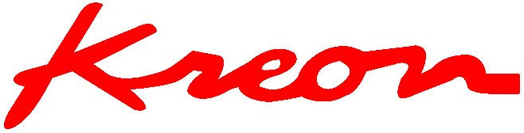 Limoges, 9th of May 2023

PRESS RELEASE

**ONYX, the KREON measuring arm**

[*Kreon*](https://kreon3d.com) *is innovating and unveiling the* [*Onyx measuring arm*](https://kreon3d.com/scanning-arms-portable-cmm/onyx-high-precision-measuring-arm/) *during the Control fair held in Stuttgart (Germany)*

With its completely new product architecture, the Onyx measuring arm is packed full of innovations. It manages the 3D acquisition of parts with unequalled efficiency and ease. With its exceptional precision, the Onyx measuring arm also ensures perfect control of production quality, whatever the application or industry concerned.

A measuring arm designed to be at the forefront

The Onyx arm impresses with its outstanding capabilities, which are the result of a design that exploits the most cutting-edge technologies. Firstly, the use of high resolution encoders gives it the highest accuracy of any Kreon measuring arm. Secondly, the presence of numerous carbon fibre structural parts makes the arm considerably lighter, which improves the user experience. Finally, the simplified and more rigid assembly of the Onyx arm makes it extremely reliable and durable, for flawless measurement results even in the most challenging environments. Powerful, ergonomic, and reliable, it has every quality needed to offer total confidence in 3D inspections carried out with an optimal level of productivity.

*The best in 3D scanning with Skyline scanners*

Combined with the [top-of-the-range Skyline 3D scanners](https://kreon3d.com/3d-scanners/skyline/), the Onyx measuring arm forms a high-performance 3D scanning system. Thanks to their speed, resolution and precision, the Skyline 3D scanners scan all types of parts with record productivity. The blue laser technology and the HD camera make it possible to scan a wide variety of surfaces, even the most difficult ones (shiny black, metallic or carbon), without loss of accuracy. With Skyline scanners, there is no need to place targets on your parts or use a matting spray, which, in turn, means significant time savings. As a result, industrial parts of any size will be scanned easily and in great detail.

*Unprecedented ease of use*

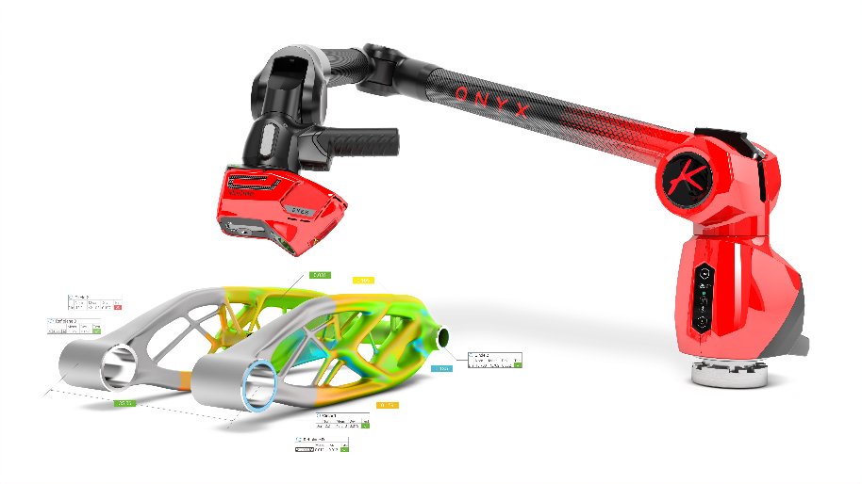Thanks to the feedback from its many product users, Kreon has been able to design new features to ensure the best possible user experience with the Onyx arm. The EasyClip handle was developed for this purpose. It can be removed at the touch of a button, reducing the size of the end of the arm and making hard-to-reach areas accessible and measurable. In addition, the QuickView touchscreen at the base of the arm provides tight control over the measurement process. It gives the user an overview of the measurement conditions by displaying the battery level, ambient temperature and arm status, and via the WiFi and Bluetooth control. For wireless operation, the Onyx measuring arm is also equipped with a battery that can be hot-swapped, without interrupting the workflow.

The versatile Onyx measuring arm can be used with a probe or a 3D scanner, and operated in the inspection room or in the workshop. It is suitable for all applications (quality control, reverse engineering, etc.) and will be a welcome addition across all industries (automotive, aerospace, etc.). The Onyx arm's lightness and sophisticated ergonomics offer unparalleled ease of use and productivity.

**The Onyx measuring arm will be available in the last quarter of 2022, in 6 and 7 axis versions, in sizes ranging from 2m to 5m.**

|  |
| --- |
| **About Kreon** |
| Kreon is a French contact and non-contact 3D measurement solutions supplier.  Specializing in 3D scanners for 30 years, the company also offers measuring and scanning arms, and tracking solutions. Its laser scanners are compatible both with measuring arms and CMMs. Its solutions have been integrated into leading application software of the market.  Kreon Technologies' know-how combines high-tech products and high level of service. The company is committed to providing customers performing solutions in order to help them reduce production costs and time, to increase efficiency and to improve their processes.  Kreon relies on a wide network of resellers all over the world to stay close to its customers and to offer customized solutions  Find out more about Kreon products: [www.kreon3d.com](http://www.kreon3d.com)  or call us at +33 555 428 040 |